Directed by Michael Glass and established in 1982. | 4-Day Summer Programs  At Albany Recreation, JCC East Bay, Heather Farm,Walnut Creek, and Lafayette Parks & Rec.  Summer Schedule 2019

Come join us this Summer in: Albany, Berkeley, Walnut Creek and Lafayette. Kids’ Carpentry is a year-round enrichment program designed to teach girls and boys, kindergarten-6th grades (summer entering K-7th), the safe-use of hand tools and general woodworking skills. Through a sequence of projects, the young carpenters gain the skill and competence to complete increasingly more complicated projects after first completing their sanding block and super-top. From boats to bird feeders, doll furniture, clocks, games, airplanes, and many more, the kids have a wide range of projects to choose from besides designing and building according to their own needs and imagination for the veteran carpenter.
In addition to the fun kids have they also gain quality experiences in measuring, applied math (including fractions), problem-solving, craftsmanship, and empowered by the hands-on experience.
Carpentry classes are taught with two teachers for every 10-12 students, ensuring careful attention and respect for each child. Since class sizes are limited, prompt enrollment is strongly recommended.

Summer Classes are taught Mondays-Thursdays
 | Session 1. June 10-13 Heather Farm  Session 2. June 17-20. Lafayette Parks and Rec  Session 3. June 24-27. JCC East Bay, (tenative)  Session 4. July 1-5. Heather Farm (no class 7/4)  Session 5. July 8-11. Lafayette Parks and Rec.  Session 6. July 15-18. Albany Recreation  Session 7. July 22-25. Heather Farm  Session 8. July 39- Aug.1. Lafayette Parks and Rec.  Session 9. August 5-8. Albany Recreation  Session 10. August 12-15. Heather Farm  Summer Class Times:  9:30-11:00; 11:00-12:30; 12:30-2:00.  Summer Classes are taught by director Michael Glass and his super talented wife, Jeab | 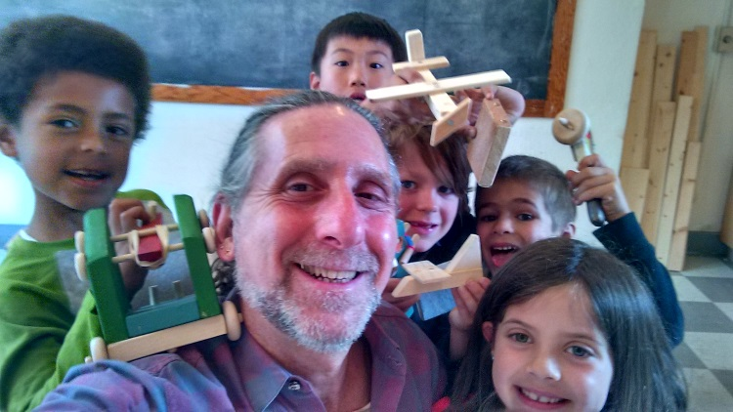
To Register call:
Heather Farm, Walnut Creek (301 N. Carlos Drive) call: 925-943-5858.
Lafayette Parks and Recreation (500 St. Mary’s Rd.) call: 925-284-2232.
Albany Recreation (1249 Marin Ave., Albany) call: 510-524-9283
JCC East Bay (1414 Walnut St., Berkeley) register on line at: www.kidscarpentry.com

Our Motto: Building confidence and teaching with respect and humor in a safe and happy environment.
Check out our web site at: www.kidscarpentry.com

